Arcade Helicopter light v0.2

**Quick Start Guide.**

English.

This asset is designed to facilitate the creation of the logic of the behavior of helicopters or other game objects that are similar to them in behavior. This is a simplified version of the asset. With it, you can create only a simplified model of behavior that does not completely imitate the physics of the behavior of a helicopter.

Asset contains several scripts, but to create a working model of the helicopter you will need only one. "Helicopter Controller". All other scripts are needed to run the demo scene.

**Preparing the model.**

1. Create an empty scene in the project and place on it a model of your helicopter.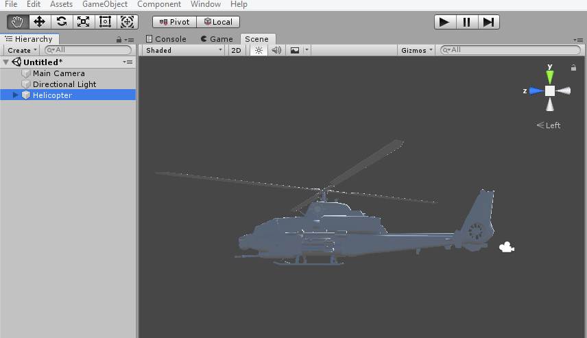Position the model so that the orientation of the model matches the orientation of the Unity space axes.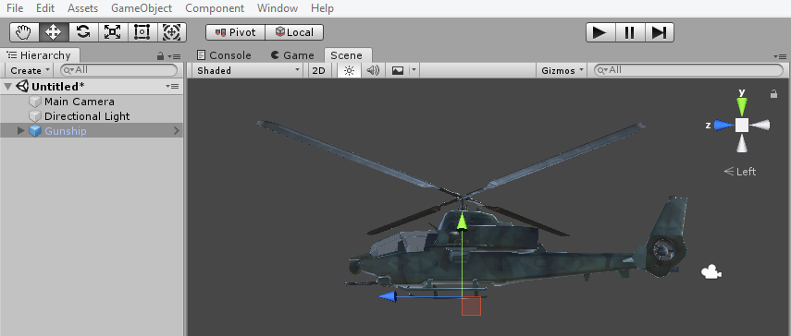
2. Create an empty, subsidiary helicopter object and name it "Landing". Add a Box Collider component to it.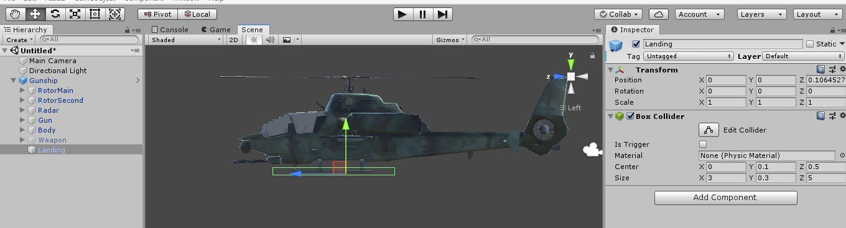   
   This collider will monitor the fact of a helicopter landing. Set its location so that the helicopter does not roll on its side when working physics. Even if the helicopter falls to the ground from a height.
3. Add the “Rigid Body” component to the helicopter and set the following settings in it.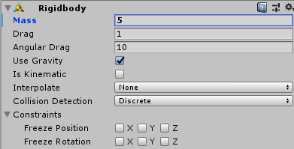
4. Add the “Audio Source” component to the helicopter and assign an audio clip with the sound of the screws rotating.

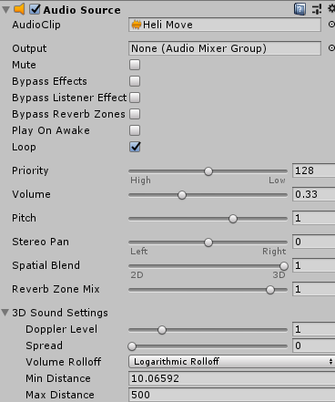

1. Add the script "Helicopter Controller" to the helicopter. We will look at its settings later.
2. Add to the helicopter all the other necessary colliders who will track the collision of the helicopter with various objects on the scene.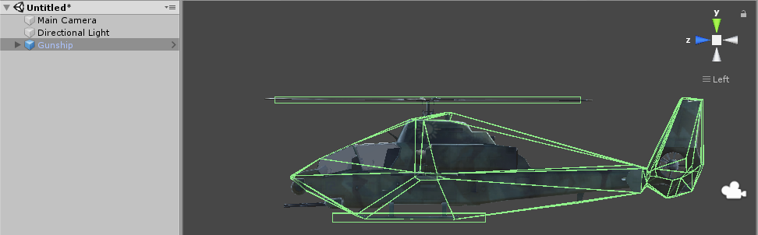Remember that the size and location of each collider affects the physics of helicopter behavior. Be careful in this matter and get an adequate helicopter response.

As a result, you should get about this result.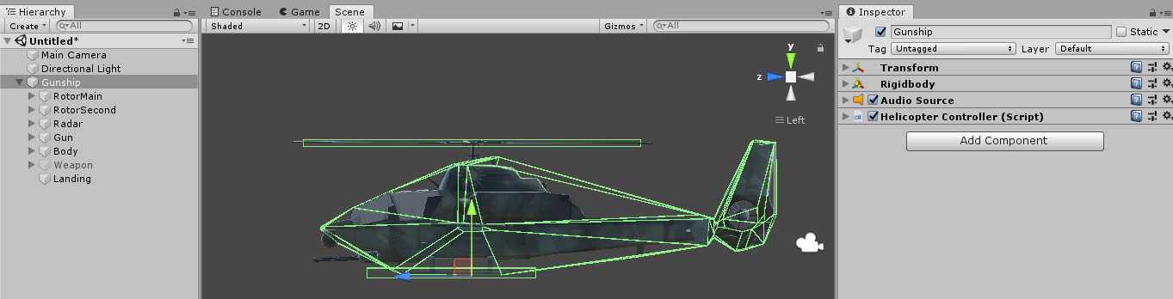

**Script Settings "Helicopter controller".**

**Work only when the mouse cursor is hidden.**



If this flag is set. The helicopter will respond to pressing the control key only if the mouse cursor is hidden.

**Launch a helicopter in the air.**

  
If this flag is set, the helicopter will appear in the game immediately with the engine running at 100%. This is convenient if you want to start the game not on the ground, but immediately in the sky.

**Hold altitude.**

  
If this flag is set, the helicopter will strive for a given height and hold it. The holding height is assigned at the moment of changing the “hold height” mode, and can also be changed by scrolling the mouse during the flight.

**Use of radio altimeter.**

  
If this flag is set, the current altitude calculation comes from the obstacle that is under the helicopter. If the flag does not set the current height, the value is Transform.position.y.

**Auto stabilization of the helicopter.**

  
If this flag is set, the helicopter will automatically level its tilt angles if the player has not pressed the tilt control key. Each axis is accounted for separately.

**Auto turn.**

  
If the flag is set, the helicopter will automatically rotate towards the focus of the camera. This works if the player does not press the control keys of the helicopter. Each axis is accounted for separately.

**Collider landing.**

  
This collider serves to determine whether a helicopter has landed or not. In the event that a collider collides with the objects of the scene, the helicopter does not push aside, and the script does not work out the keys for tilting the helicopter.

**The intensity of horizontal flight.**

  
This value determines how fast the helicopter will move in horizontal planes.

**Stabilization rate.**

  
This value determines how quickly the helicopter will level the tilt along the axes, if the control keys of the helicopter are not pressed. Does not work if Auto Rotate is enabled (Looking == true).

**Limit lift.**

  
The maximum allowable value of the lifting force of the helicopter. The player can increase or decrease the lift force by scrolling the mouse. This value sets the available range (for example, -10 and 10).

**Correction of the mass of the helicopter.**

  
Since collider has its influence on the physical model of the helicopter, to maintain the ability to "hang" at the same height, it is necessary to correct the current mass of the helicopter with this value. Change this value after you have set all colliders and configure all other parameters of the helicopter. Stay on the stable hovering of the helicopter with the variable UpForce == 0.

**Maximum height.**

  
Set limits for the maximum height that a helicopter can climb in your game. Do not forget that if the helicopter will use Radio Altitude then the maximum height will be calculated from the obstacles under it and this value may not coincide with the current value of Transform.position.y.

**Repulsive force.**

  
The force with which the helicopter will push off from an obstacle in the event of a collision. This works for all collectors except Landing Collider.

**The sensitivity of the scroll mouse.**



**Collision mask under the helicopter.**

  
This mask is used by the beam, which is launched “under the helicopter” to determine the current radio altitude.

**The rate of change of engine power.**

  
Determines how fast the engine changes its power from the current to the specified one.

**Correction of the sound of rotation of the screws.**



If the sound of rotation of the screws does not coincide with the speed of rotation of the screws, this parameter should be corrected.

**Setting rotors.**

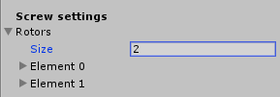

Add ships to as many array elements as the rotors of your helicopter.

Adjust each rotor according to your requirements.

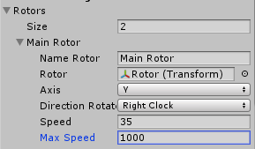

**Name Rotor** - The name of the rotor.

**Rotor** - Link to the transform of the rotor that will rotate.

**Axis** - The axis of rotation of the rotor.

**Direction Rotation** - Direction of rotation (clockwise or counterclockwise)

**Speed** ​​- Rotation speed at 1% engine power.

**MaxSpeed** ​​- The maximum possible speed of rotation of the blades.

**Helicopter tilt speed settings.**

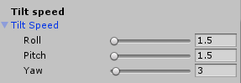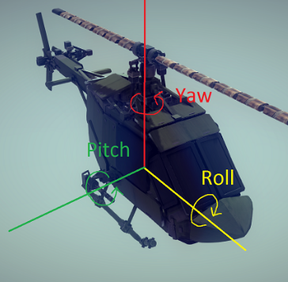

The speed with which the helicopter changes the angle of inclination along the axes.